CALC II - EXAM #1 CONSOLIDATED NOTES

5.1 – Area is the limit of infinite rectangles.
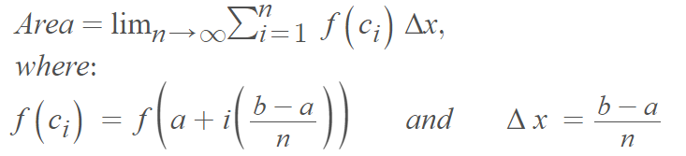
Also see limit rules. Appendix A.
5.2 – Definite Integrals. Also follow above definition.
Evaluated by FTC Part 2. Watch for zero in the denominator: asymptote.
Absolute value broken into a positive and negative integral.
Also see integral rules. Appendix B.
5.3 – FTC Part 1, Part 2: Part 1: you swap t for x
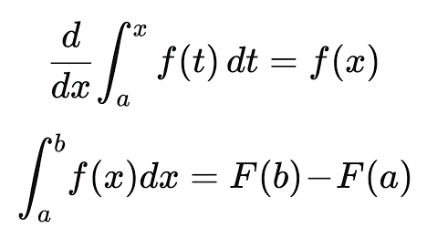Part 2: requires smooth function
5.4 – Indefinite Integrals. Take Antiderivative. A function family not a number.
When the Integral is a composition, derivative is swap plus Chain Rule of g(x).
Also see Antiderivative Sheet. Appendix C.

5.5 – The Substitution Rule.
Indefinite Integrals: 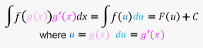
- Identify the best u(x) s.t. 3) takes out g’(x) or provides cancellation…
- Take du = dx. Solve for dx.
- Sub du for dx, cancellation
- Take Antiderivative, leaving u in.
- Sub back u = f(x).
Definite Integrals:
- Check for known functions, algebra cleanup, trig identities to use.
- Use above process.
- Sub bounds. Check where x = u and plug in x. Careful you may need twice.
- Evaluate in u. Check versus graph if provided.
Even and Odd functions: 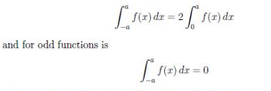
6.1 – Areas by Integration:
- Sketch the area.
- Find boundaries and/or intercepts. Set functions equal and solve if needed.
- Set up the definite integral. (Restating function to be easier. Swaps x and y.)
- Integrate. Using u sub if necessary.
When the boundaries are y values…integrate with respect to y * ---------|
You may need to solve for boundaries, y values, by using/setting x. |
Make sure the boundaries are the ones given, not just two solutions. |
Area = $\int_{c}^{d}{g\left(y\right)}$ . Find g(y) by solving for x, and subbing that y expression. *
Ignore negative radicals, remembering area is always positive.
Areas between two curves:
- Remember the bottom function is subtracted from the top function.
- Remember it’s the left subtracted from the right for horizontal elements.
- Evaluate Integral with above method.
- Always take the absolute value of the result.
6.2 – Volumes w/ Cross Sections
First draw graph of it. Then find the bounds from given or intersections. Plug in.
When the shape isn’t round, isn’t a revolution, it’s a base: use SQUARE slices
$A\left(x\right)= \int_{a}^{b}{{[f\left(x\right)-g\left(x\right)]}^{2}}$ dx FOIL out. Separate. Integrate with Power Rule
When it’s ROUND or stacked disks, use the CIRCLE AREA along the best axis for it
$A\left(x\right)= \int_{a}^{b}{{π\left(f\left(x\right)\right)}^{2}} dx$ where f(x) is the radius along the y axis of the function. FOIL
When it’s DISKS along the Y axis, the x value of f(x) is the radius. Put in terms of y by solving for x and replacing the resulting y expression for r…bounds are y values.
When it’s got a hole it’s WASHERS or SHELLS. Washers -> diff. of two Radii, areas
$A\left(x\right)= \int_{a}^{b}{πR^{2}-πr^{2}}dx$ where radii are f(x) and the other is g(x) or constant. FOIL…
When it’s WASHERS along the y axis, use method above with washer fomula.
R is the bigger radius and may be fixed while r is changing.
6.3 – Volumes with Cylindrical Shells
It’s about the best “curve-defining shape”. Try washer first, quit if becomes hard.
f(x) is the height, circumference is 2πr, the thickness is dx
$V=\int_{a}^{b}{2πr*h*dx}$ bounds [a, b] from the outer edge of hole to the outer edge
If it’s along x-axis then r is x. Left to right so it’s dx.
If it’s along y-axis then you solve for x in terms of y and replace f(x) with that so
$V= \int_{a}^{b}{2πy*f\left(y\right)*dy}$

6.5 – Avg. Value of a Function
Infinitely many things i.e. temperature. n in avg. replaced by the integral length
$f_{ave}= \frac{1}{b-a}* \int_{a}^{b}{f(x)}$ plug in [a, b], take antiderivative, and then evaluated at b – a.
There are problems where they give you f(x) and you have to find a bound.
Get it into a formula with evaluated at. Get it to a quadratic = 0. Use quadratic formula.
7.1 - DIS Method for Integration by Parts
Set up $\int{u dv}$ . The D column is u. The I column is dv. The S column starts with +.
Usually the u is the polynomial, the dv is infinitely integrable.
Take the derivative down the first column to 0, or until I column repeats.
Take the Integral down the I column. The sign alternates down the S column.
The completed integral is the product of D I S down the diagonal. (or across)
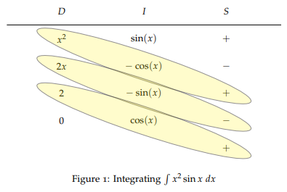
If D doesn’t go to 0, you take a horizontal slice and integrate that, when:
- a row repeats, ignoring coefficients and signs, OR
- the second row can be integrated by itself
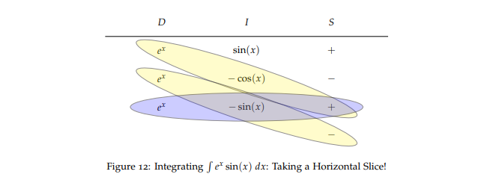
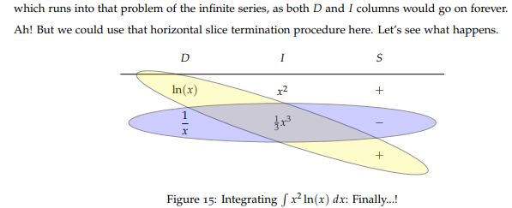
If you have to do the horizontal slice remember to do the integral correctly, you may have some algebra to do before you integrate. Remember the rules. Check.
7.2 – Trig Integrals. There’s a recipe for each one. Memorize special cases.
Work with it. Use P.I. when you don’t have any other moves.
You are trying to get it into the best position for a u-sub.
For higher degrees, it will always be possible to factor it into a given form/rule.
You use trig reasoning triangle whenever you have an intermediate answer or the antiderivative sitting in theta. Look for when you are done except for going to x.
Your du or dΘ should match where you are in the substitution.
Memorize the following sheet, it is what’s being tested for these two sections:
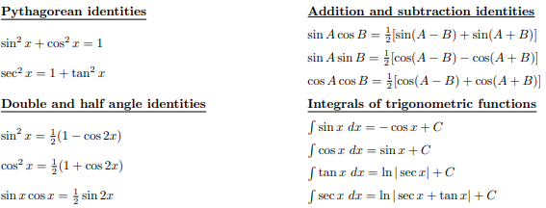
Trig Forms/Rules: Use ID first, then the Trig Sub
Form | Trig I.D. | Trig Sub
$\cos^{n}$, is odd | P.I. | U = sinx
$\sin^{n}$, is odd | P.I. | U = cosx
$\sin^{n}\cos^{n}$, is even | Half-Angle ID | Expand, Repeat
$\tan^{n}$, is odd | P.I. | U = secx
$\sec^{n}$, is even, n = 2 |  | U = tanx
$\sec^{n}$, is even, n $≥$ 4 | factor $\sec^{2}x$, P.I. on the rest | U = tanx
sinxcosx | Addition/Subtraction
sinxsinx | Addition/Subtraction
cosxcosx | Addition/Subtraction
If you get a product after the ID, expand into two integrals.
7.3 – Trig Substitution.
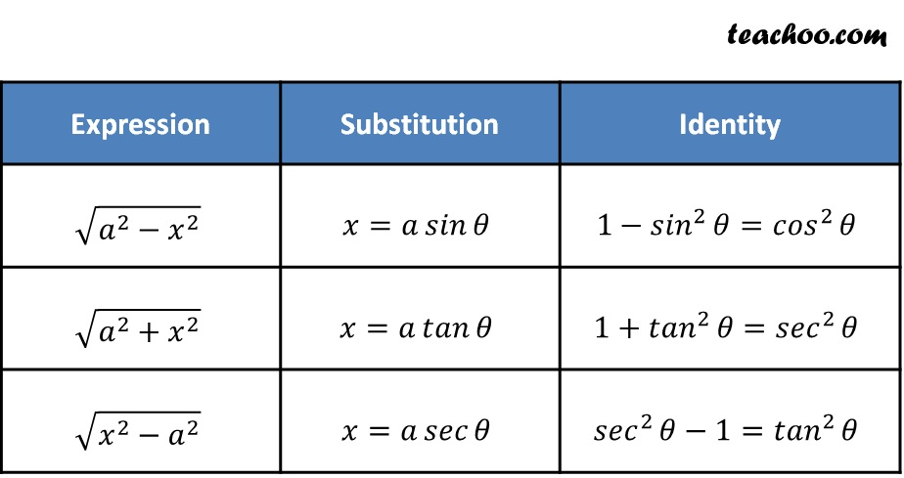
Vanilla Trig Substitution:
- Trig sub above, sub bounds using unit circle
- Identify a, dx, solve for Θ.
- Factor and u-sub, v-sub, until you can Integrate
- Integrate
- Triangle back with Θ -0ol,to x, with P.I.
Quadratic Trig Sub:
- Complete the Square (divide linear coeff. By 2 and square, + and – it, factor)
- U-sub (also find x and du to do it)
- Trig sub for u, sub bounds using unit circle
- Factor and P.I.
- Integrate
- Sub backwards from Θ to u to x
7.4 – Integration by Partial Fraction Decomposition
Proper Fractions:
- Factor the denominator
- Decompose the fraction (just write A’s and B’s, for each linear factor)
- “Count up”, term for as many as exponents
- Bowtie all, Set it equal to numerator, Expand.
- Solve for A and B with roots
- U-sub, with new A and B values
- Integrate the decomposed fractions
Improper Fractions:
- Polynomial Long Division
- Factor over and over until you get to repeated factors
- Steps 2-7 above
The U-sub can come at any time, for instance to rationalize denominator
Setting equal to the numerator can be piecemeal, to the linear factors and constants
Distinct Irreducible Quadratic Factors:
Rules as above, except irreducible gets one term with linear factors
Repeated Irreducible Quadratic Factors:
Rules as above, except “Count up” too.
7.5 – The strategy for taking integrals
is 6 Steps, always to get to an easy integral:
- Known integral? A special case?
- Graph? Can you use a graph?
- Alg/Trig Clean Up first?
- Even/Odd function?
- U-sub? Don’t do this first.
- Integration by Parts
7.8 –Improper Integrals
Two Types: 1) Definite Integral over inf. interval, OR 2) f(x) has inf. Discontinuity
Type 1, Infinite Interval:
- Sub t for infinity
- Integrate
- Evaluate at
- Take the Limit, if it exists
It’s the limit of integrals over finite intervals, to infinity, or negative infinity.
Convergent: if the limit exists ex: $\frac{1}{x^{2}}$
Divergent: if the limit DNE ex: $\frac{1}{x}$
The difference here is how fast the area approaches 0, to have a finite area.
F must be a positive function.
1 to inf is usual bounds. Watch for 0 to inf this may diverge.
P-test: for $\int_{1}^{∞}{\frac{1}{x^{p}} dx}$
p $>$ 1 is convergent.
p $≤$ 1 is divergent.
Type 2, Discontinuous Integrals:
The region is infinite in a vertical direction, not a horizontal direction
If f is continuous on [a, b) and discontinuous at b:
$A\left(t\right)= \int_{a}^{t}{f(x)} dx$ = $\lim_{t→b^{-}}{\int_{a}^{t}{f(x)} dx}$ definite, where b is vertical asymptote
If the limit exists.
If f is continuous on [a, b) and discontinuous at a:
$A\left(t\right)= \int_{a}^{t}{f(x)} dx$ = $\lim_{t→a^{+}}{\int_{a}^{t}{f(x)} dx}$ definite, where a is vertical asymptote
If the limit exists.
The CAN be a discontinuity at c inbetween, it’s just broken into two integrals
f need not be a positive function. Can have any kind of discontinuity at b.
t is put in place of the discontinuity (a, b or c), take the integral, Evaluate at
then take the limit
Comparison Test:
When impossible to find exact value of the integral. Ex: not a standard integral.
This is to know if C or D.
f and g are continuous functions $f\left(x\right)≥g\left(x\right)≥0 for x≥a$
Smaller than convergent is convergent
Bigger than divergent is divergent

You can also split a definite integral on an infinite interval into two integrals
ex $\int_{0}^{∞}{e^{{-x}^{2}}dx}= \int_{0}^{1}{e^{{-x}^{2}}dx}+ \int_{1}^{∞}{e^{{-x}^{2}}dx}$
The first as ordinary, say from 0 to 1
The second from 1 to $∞$
For the second use reasoning to find if it’s smaller than some ordinary integral you can take. If that is smaller than convergent, its’ convergent and vice-versa
So for x $≥1$, we have $x^{2}≥x, so {-x}^{2}≤x, and therefore e^{{-x}^{2}}≤e^{-x} .$
The integral of $e^{-x}$ is easy to evaluate:
Take the limit of definite integral from 1 to t evaluated at 1 to t, subbing infinity
The Reverse Chain Rule makes the leading -1 coefficient appear.
They switch places, you plug in for the limit, and you get the convergence of $e^{-1} .$
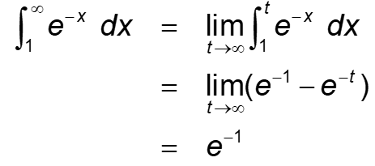
Since this is a convergent integral greater than $\int_{1}^{∞}{e^{{-x}^{2}}dx}$
We have two convergent pieces and the overall integral is convergent.
Just find an easier integral obviously bigger and start:
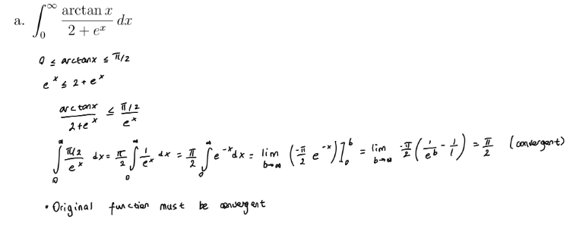

Appendix A – Limit Rules
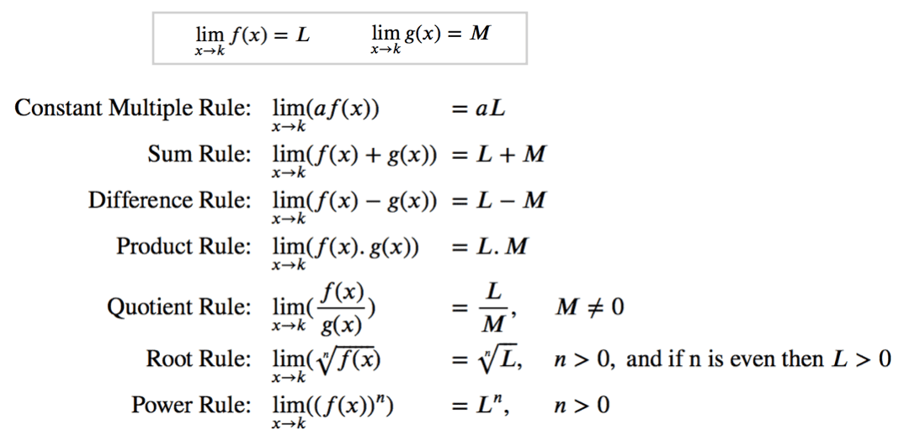

Appendix B – Integral Rules
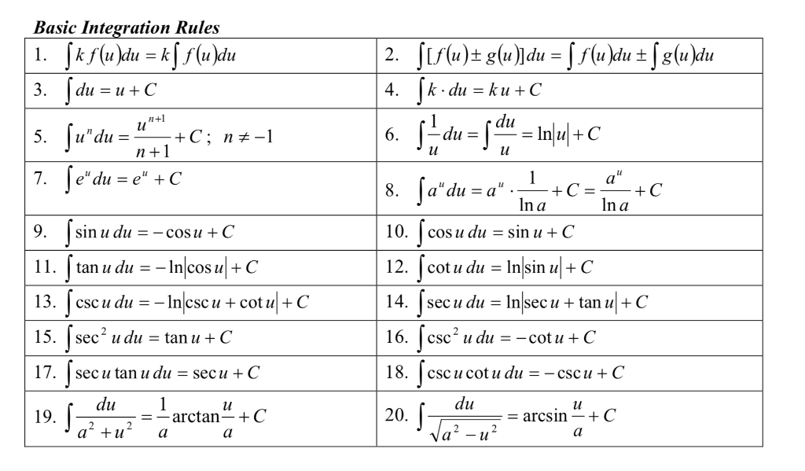

Appendix D – From Betul

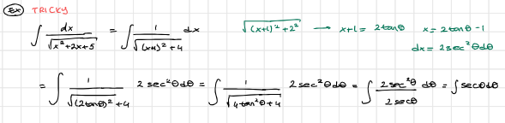
X+1 is the x term for the trig sub

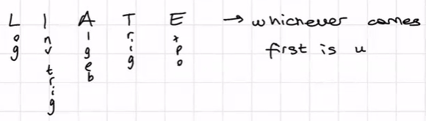
Whichever is prior on the list is the u

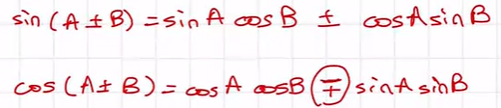
The cos one has an opposite +/-

